**Lab 3**

Alec Wood

SDEV 300: Building Secure Python Applications

November 9th, 2021

|  |  |  |  |  |
| --- | --- | --- | --- | --- |
| Test Case | Input | Expected Output | Actual Output | Pass/Fail |
| 1 | Option 1 | List all states | List all states | Pass |
| 2 | Option 2  Texas | Texas | Texas | Pass |
| 3 | Option 3 | California, Texas, Florida, New York, Pennsylvania | California, Texas, Florida, New York, Pennsylvania | Pass |
| 4 | Option 4  Texas  1 | Texas with Population 1 | Texas with Population 1 | Pass |
| 5 | Option 5 | Exit | Exit | Pass |

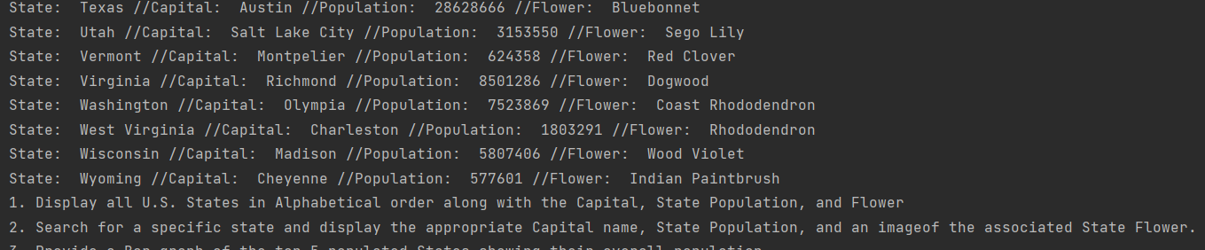

End of state list and redisplay of menu

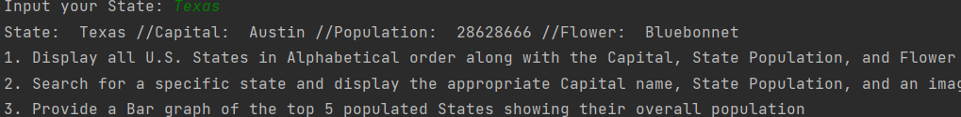

Texas displayed after option 2 selection

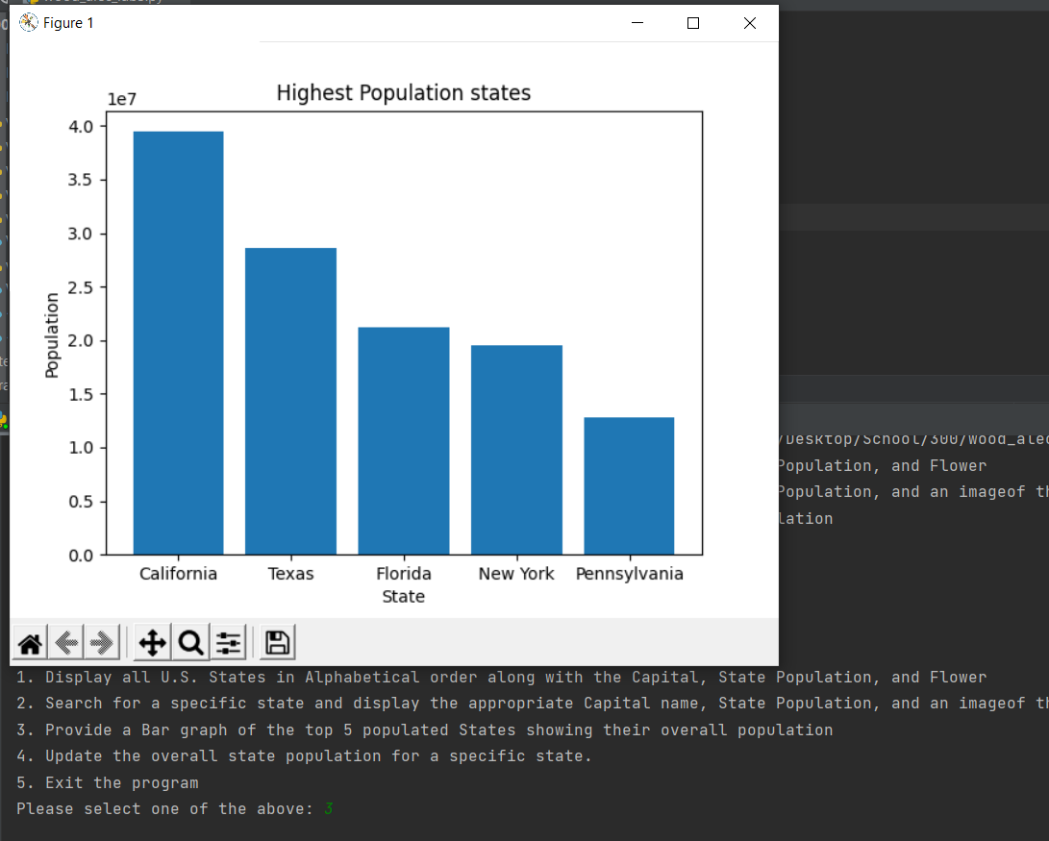

Graph displayed after option 3 selection

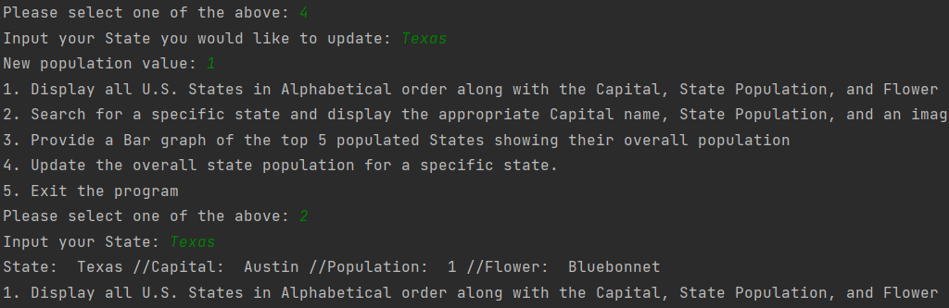

Shows option 4, population updated to 1 and redisplayed with new population once option 2 was selected again.

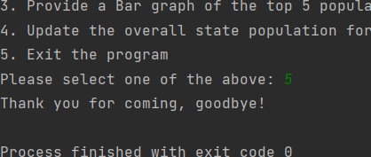

Program Exit on option 5.

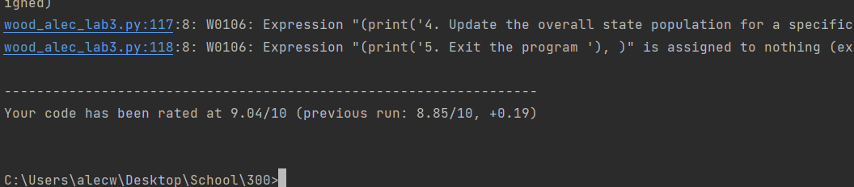

Could not figure out how to surpass the W0106 error from pylint.